

Home work

6.3,6.4,6.5, Exercise



**November 11, 2020**

**RAIHAN MD RAKIBUL ISLAM**

**2020380029**

**6.3**

6. Find the value of each of these quantities.

a) C (5, 1)

**A:5**

b) C (5, 3)

**A:10**

c) C (8, 4)

**A:70**

d) C (8, 8)

**A:1**

e) C (8, 0)

**A:1**

f) C (12, 6)

**A:924**

14. In how many ways can a set of two positive integers less than 100 be chosen?

**Sol:** The order of the integers in a set is not important (since a different order of the elements in a set remains the same set), thus we need to use the definition of combination.

There are 99 positive integers less than 100, of which we want to select 2.

n = 99

r = 2

Evaluate the definition of a combination: **C (99, 2) =**  = **4851**

24. How many ways are there for 10 women and six men to stand in a line so that no two men stand next to each other? [Hint: First position the women and then consider possible positions for the men.]

**Sol: First line up the 10 women**

The order of the people is important; thus, we need to use the definition of permutation.

n = 10

r= 10

Evaluate the definition of a permutation:

**P (10,10) =**

**Next line up the 6 men**

The order of the people is important; thus, we need to use the definition of permutation. There are 11 positions between the women (on either side of all women and between each of the 9 pairs of consecutive women), while we need to select 6 of those positions for the men.

n= 11

r = 6

Evaluate the definition of a permutation:

**P (11,6) =**

Ways to line up the women: 10! =3,628,800

Ways to line up the men: = 332, 640

Use the product rule: **Total** =10! * = 3, 628, 800 x 332, 640 = **1, 207,084, 032, 000**

34. Suppose that a department contains 10 men and 15 women. How many ways are there to form a committee with six members if it must have more women than men?

**Sol:**

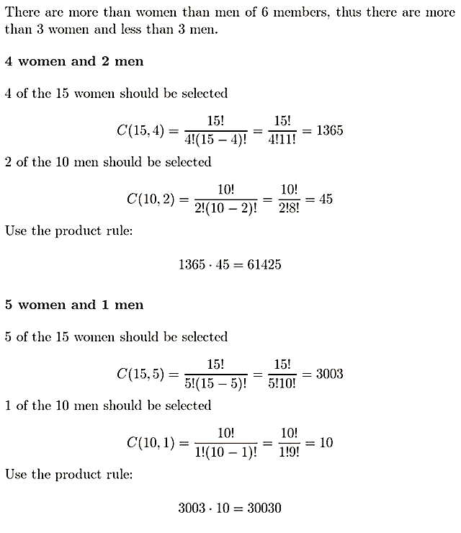

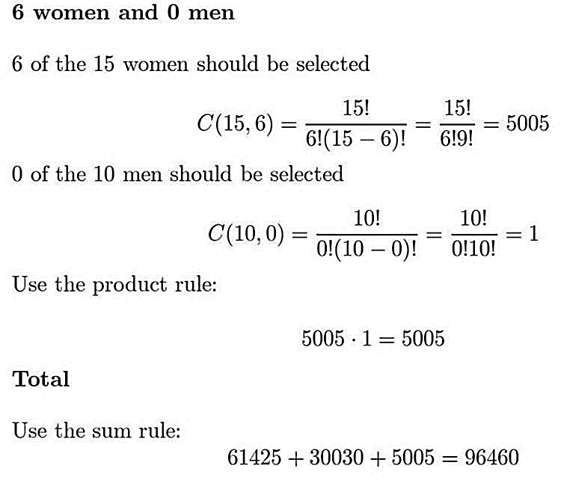

**6.4**

6. What is the coefficient of in ?

**Sol:**

n = 11

j = 7

The coefficient term is: **() =**

18. Suppose that b is an integer with b ≥ 7. Use the binomial theorem and the appropriate row of Pascal’s triangle to find the base-b expansion of [that is, the fourth power of the number (11)b in base-b notation].

**Sol:**

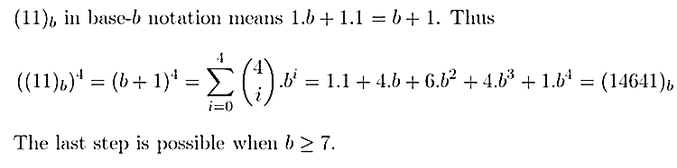

**34.** Use Exercise 33 to give an alternative proof of Corollary 2 in Section 6.3, which states that () = whenever k is an integer with 0 ≤ k ≤ n. [Hint: Consider the number of paths of the type described in Exercise 33 from (0, 0) to (n − k, k) and from (0, 0) to (k, n − k).]

**Sol:**

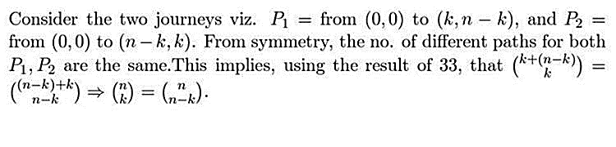

**6.5**

8. How many different ways are there to choose a dozen donuts from the 21 varieties at a donut shop?

**Sol:**

n = 21

r = 12

C (n+r-1, r)

= C (21+12-1,12)

= C (22,12)

= **225,792,840**

12. How many different combinations of pennies, nickels, dimes, quarters, and half dollars can a piggy bank contain if it has 20 coins in it?

**Sol:**

n = 5

r = 20

C (n+r-1, r)

= C (5+20-1,20)

= C (24,20)

= **10,626**

32. How many different strings can be made from the letters in AARDVARK, using all the letters, if all three as must be consecutive?

**Sol:**

AARDVARK = 8

A = 3

R = 2

D = 1

V = 1

K = 1

The string contains then 6 letters od which AAA=1, RR=2, D = 1, V = 1, K = 1

n = 6

k = 5

= 1

= 2

= 1

= 1

= 1

**= = = 360**

36. How many different bit strings can be formed using six 1s and eight 0s?

**Sol:**

n = 6+8 = 14

k = 2

= 6

= 8

**= = = 3003**

Exercise

1.How many positive integers not exceeding 1000 are divisible either by 3 or by 5?

**Sol:**

There are 333 positive integers divisible by 3 in 1000.

There are 200 positive integers divisible by 5 in 1000.

There are 66 positive integers that are divisible by both 3 and 5.

So, the number of positive integers less than 1000 divisible by 3 or 5 is

=333+200 – 66 = **465**

1. 2.A palindrome is a string whose reversal is identical to the string. How many bit strings of length *n* are palindromes?
2. **A:** 
   1. i)There are 3500 fresh students in NWPU. If we assume difference between birthday of any two students are less than 365*2. Can we draw following conclusion? Any student can find another one was born in the same day (refer to same year, month and day). How many students at least were born in the same day?
   2. **Sol:**

Total fresh student of NWPU = 3500

two students are less than 365*2 = 730

So, students at least were born in the same day = = 4.794 ≈ **5**

* 1. 3.Pick 5 integers from 1 to 8, inclusive. Show the two of them sum to 9.

**Sol:** If we want the sum to be 9, consider the sets {1,8}, {2,7}, {3,6}, {4,5} each with sum 9. If we choose 5 numbers, two of them must belong to the same set.

* 1. 4.Let A= {0,1,2,3,4,5,6,8,9}. Show that any 7 sets in P4(A) contain two subsets with the same largest element.

**Sol:**

* 1. There are 4 elements in P4(A) subset
  2. The largest must element must great or equal to 3
  3. it comes from {3,4,5,6,8,9}
  4. If we select 7 subsets then there must be largest element.
  5. 5.How many bit strings of length 10 contain at least three 1s and at least three 0s?

**Sol: Total Strings of length 10**

* 1. = 1024
  2. We should select 0 one’s from the 10 digits
  3. C (10,0) = 0
  4. We should select 1 one’s from the 10 digits

C (10,1) = 10

We should select 2 one’s from the 10 digits

C (10,2) = 45

The strings of length 10 contain at least three 1s and at least three 0s

So, bit strings = 1024-1-1-10-10-45-45= **912**

* 1. 6.Suppose that a department contains 10 men and 15 women. How many ways are there to form a committee with six members if it must have the same number of men and women?

**Sol:**

n = 10

r = 3

C (10,3) =120

n = 15

r = 3

C (15,3) = 455

Total: 120 * 455 = **54,600 ways**

7.How many solutions does the equation?

*i) x*1+ *x*2+ *x*3+ *x*4= 15

have, where *x*1, *x*2, *x*3and*x*4are nonnegative integers?

How many solutions does the equation?

**Sol:**

n = 4

r = 15

C (n +r-1, r)

= C (15+4-1,15)

= C (18,15)

=**816**

*ii) x*1+ *x*2+ *x*3+ *x*4= 15

have, where *x*1, *x*2, *x*3 and *x*4 are positive integers?

**Sol:**

*x*1’ = *x*1-1

*x*2’ = *x*2-1

*x*3’ = *x*3-1

*x*4’ = *x*4-1

n = 4

r =(x1’+x2’+x3’+x4’-n) = (15-4) = 11

C (n +r-1, r)

= C (11+4-1,11)

= C (14,11)

= **364**

8.How many different strings can be made by reordering the letters of the word *Chinese Cheese*?

**Sol:**

Chinese Cheese = 13

C =2

H =2

I =1

N =1

E = 5

S = 2

**Total strings = = 6,486,480**